**ROYAL COLLEGE NAMUGONGO**

END OF TERM THREE EXAMINATION

GEOGRAPHY SENIOR ONE

***TIME*:** 2 HOURS

**NAME…………………..................SIGNATURE…………**

**Stream ……………………………..**

**Instructions;**

* This Paper consist section A and B
* Section A is compulsory.
* Attempt any one question from section B
* Answers should be written on the answer sheets provided. Neatness and clear presentation of ideas as well as use of relevant illustrations leads to more scores.

**SECTION A**

1. Chemutai Faustine in his career of studying geography to become a pilot visited a meteorological center and found the following equipment installed at different positions. He then went back to his village and planned to mobilize the youth farmers to set up the same to overcome many climatic changes. The youth agreed to set up a weather station to overcome uncertainties of weather.

** Campbell**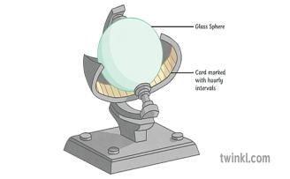

**Rain gauge**

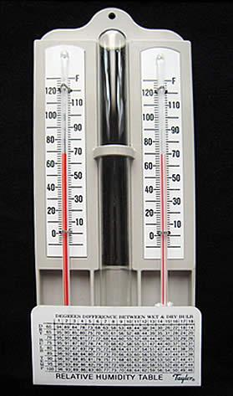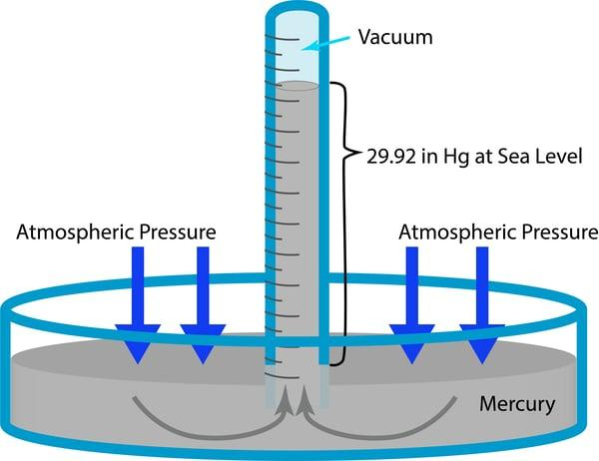**Barometer**

**Hygrometer**

How did they use the following instruments?

1. Rain gauge **(04 marks)**
2. Campbell sunshine recorder **( 04 marks)**
3. Hygrometer **( 04 marks)**
4. A mercury barometer **(04 marks)**

(b) At Entebbe International Airport, the process of giving weather updates to pilots to prepare for the upcoming flight is called, ‘Briefing’. Said Faustine’s respondent. Mention four ways through which this process helps in aviation.  **(04 marks)**

1. Tom left home for school very early in the morning when it was still dark. He reached school when the sun had risen.
2. Explain to Tom why this process happened **(05 marks)**
3. Explain to Tom about the other effects of the process.  **(05 marks)**
4. What will happen to Tom’s shadow during different periods of the day? Give a reason for your idea. **(10marks)**

3. You have been chosen as a student of geography to talk about the environment of your school, during one of the school exhibitions.

(a) Explain how people in your local community affect, destruct or destroy the environment.   **(10 marks)**

(b) As a senior one geography student explain how you can advise people in your local community to preserve the environment.  **(10 marks)**

**SECTION B**

1. On 21st October 2023, a group of researchers from Royal College Namugongo visited Kasenyi Landing site and they discovered that 66.6% of fish caught from Lake Victoria is from Tanzania, 18.6% from Lake Victoria Uganda and 14.8% from Lake Victoria Kenya.

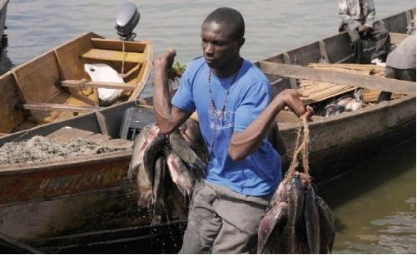

**Support material**

***Task:***

1. Explain how the researchers obtained this information. **(04 scores)**
2. Summarize the above information using an appropriate diagram. **(06 scores)**
3. The Ministry of Agriculture Animal Industry and Fisheries (MAAIF) has organized a conference to discuss about the significance of the fisheries sector of Uganda. Write a speech you would present as the Head prefect.       **(10 marks)**

1. You have read an article in the geography magazine and found a headline, “The earth’s speed around the sun is expected to be faster in 2024.”
2. Write a letter to your geography teacher and comment about this headline.    **(10 marks)**
3. Write a brief newspaper article commenting about how this movement influences human life on earth. **(10 marks)**

6.Your geography teacher asked you to carry out a field work of your choice and come up with the following.

(a) State the topic

(b)Outline the objectives of the study

          (c)Explain the methods you used to collect data.

**The End……………Good Luck**